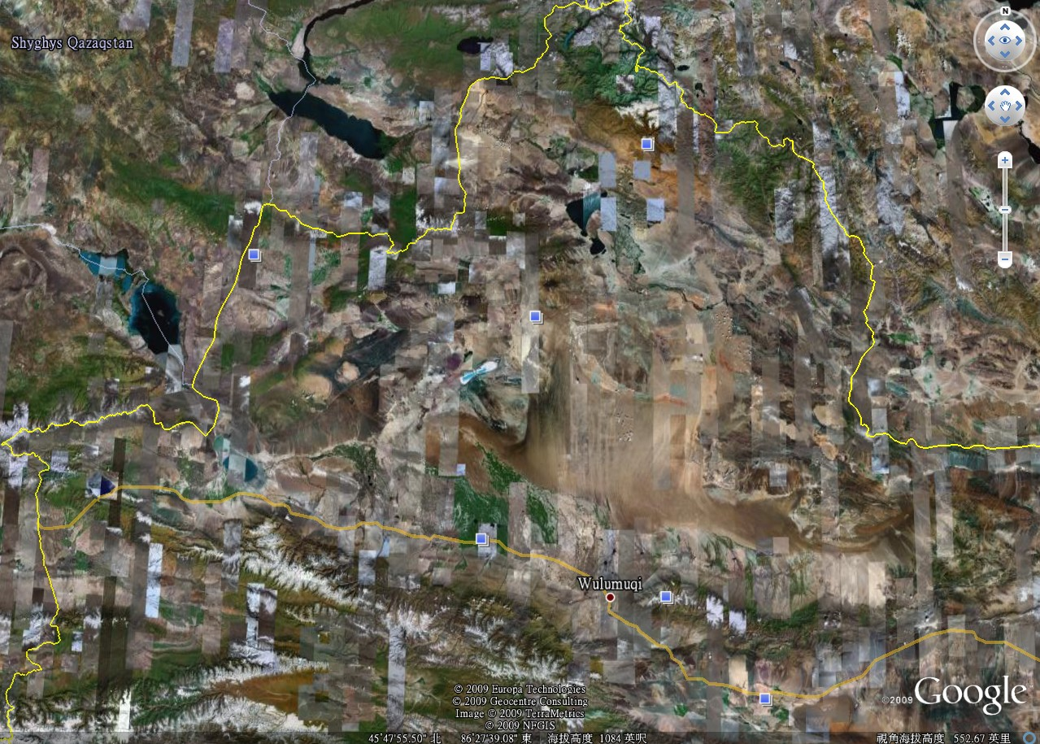
Turfan
Qi-tai
Fu-yun
Artai
Kanasi Lake
He-mu
Karamay
Kui-tun
Sailimu lake
Huogesi border
Yi-ning
Nalati
Flight:
Shenzhen <–-> Urumuqi
Land Cruiser TOYOTA 4500:
about 5000 km travel distance

